Technical Fact Sheet
Caribbean World Resorts Soma Bay, Red Sea

Caribbean World Resorts – Soma Bay, a sunny all-inclusive five star resort rested on 140,000 m2 of a blissful sandy beachfront, overlooking a magnificent crystal clear setting of the Red Sea. Featuring 604 spacious rooms with balconies of sea, or pool, garden views. It showcases 3 swimming pools, 1 mini Aqua Park, spa, 12 restaurants and bars. Offering various on-going entertainment activities, as well as daily kids’ mini disco and enjoyable live shows.

Location
Located approximately 45 km south of Hurghada International Airport and 30-minute drive to city central.

Room Accommodations & Amenities:
Resort features 604 elegantly furnished spacious guest rooms, ranging in size from 50m2 – 55m2. 87 family Suites offering an adequate amount of space of comfort of 2 separate bedrooms with a linked corridor with the size of 70m2. Pamper yourself to a luxury accommodation in our Caribbean Deluxe suits for a relaxing holiday.

All Accommodations offer:
- King or twin beds
- Individually controlled air conditioning
- LCD TV + Satellite
- International direct dial telephone
- WIFI internet access (additional charge)
- In-room safe

- Hair dryer + Shaving plug
- Shaving Mirror
- Marble walk in rain shower
- Furnished balcony or terrace
- Smoke detector + Fire Alarm
- Minibar (additional charge)

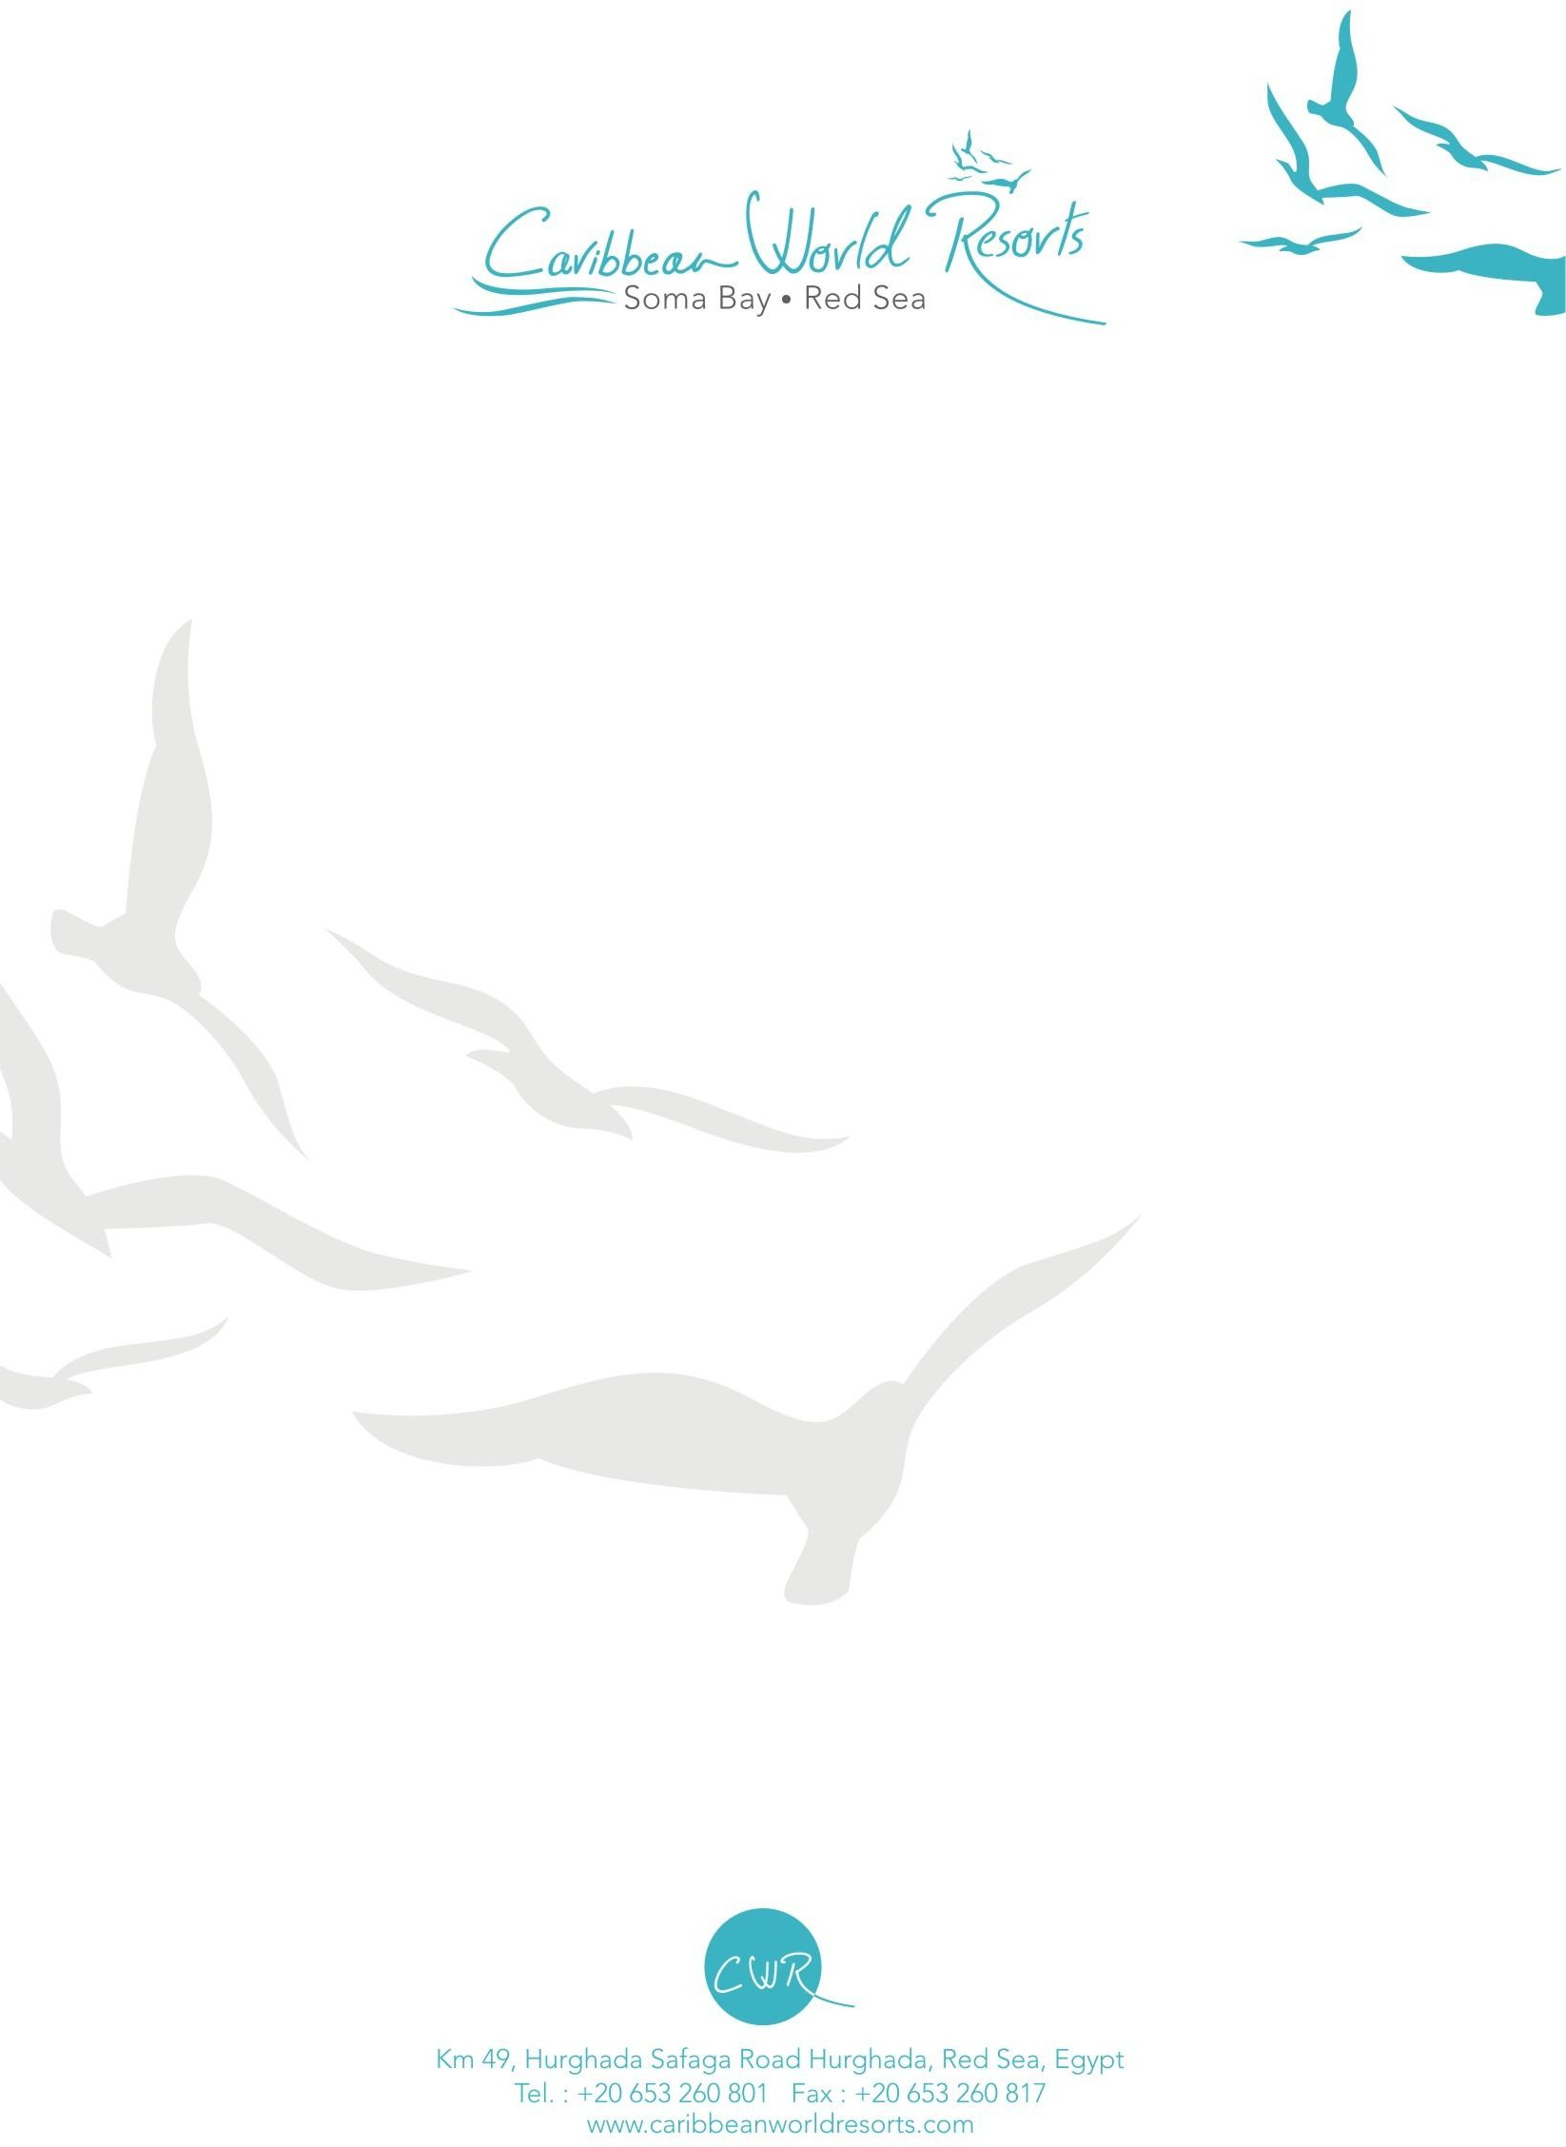
Guest Services
1
- 24 Hour front desk assistance
- Check in: 14:00 pm
- Check out: 12:00 pm (late check out with additional charge)
- Housekeeping daily service
- Wi-Fi internet coverage (with additional charge)
- ATM
- Currency exchange

- Business center
- Multilingual staff
- Laundry and pressing services (additional charge)
- Clinic (24-hour resident doctor, additional charge)
- Limousine and shuttle bus services (additional charge)

Dining Facilities:
Indulge in our diverse all-inclusive menus and alcoholic and non-alcoholic drinks with in our selection of 12 restaurants and bars. Our guests are entitled to enjoy our All Inclusive program including local alcohol day from 10:00 till 00:00 midnight, details are as follows:
Room Service is available 24 hours daily with additional charge.

Restaurants

Caribbean Main Restaurant
Breakfast, lunch, and dinner

La Palma Italian Restaurant
Dinner reservation one-day in advance
Tortuga International beach restaurant Breakfast, lunch, and dinner
BBQ Middle Eastern restaurant
Dinner reservation one-day in advance

Fish Restaurant
Dinner reservation one-day in advance with additional charge

Indoor Purple Lounge & Disco Bar:
Beverage with additional charge after midnight

Recreational Activities:
- 3 Swimming pools 1 of which is heated
- Kids heated separate pool
- Relaxing Areas available on pool & beach
- Kids Club & Playgrounds
- Variety of Shops
- 1 Amphitheater
- Aqua Park for adults + children
- One floodlight Tennis Courts (Free Daytime).
- Diving Center (with additional charge).
- Global Health Club & Spa (Sauna, Hamam, Jacuzzi & several treatments) (additional charge).
- Gym
- Diving and Aqua sport center(additional charge)
Café’s & Bars Cuba Beach bar (ice cream and snack point)
Jamaica Pool bar
Relaxing bar
Cooee Bistro Bar (additional charge)

Caribbeano Lounge & Disco Bar (In-doors)

Aladdin Shisha Lounge
(Shisha with additional charge)

Aloha Lobby bar
Coco loco Fresh Bar (additional charge)

- Planet All Sports Wind & Kite surfing center
- Animation team
- Daily evening programs
- Dance shows
- Oriental & International Theme nights
- Multi-purpose courts
- Game Area (Table Tennis & Billiards)
- Beach Volley Ball
- Darts.
- Boccia.
- Water-polo.

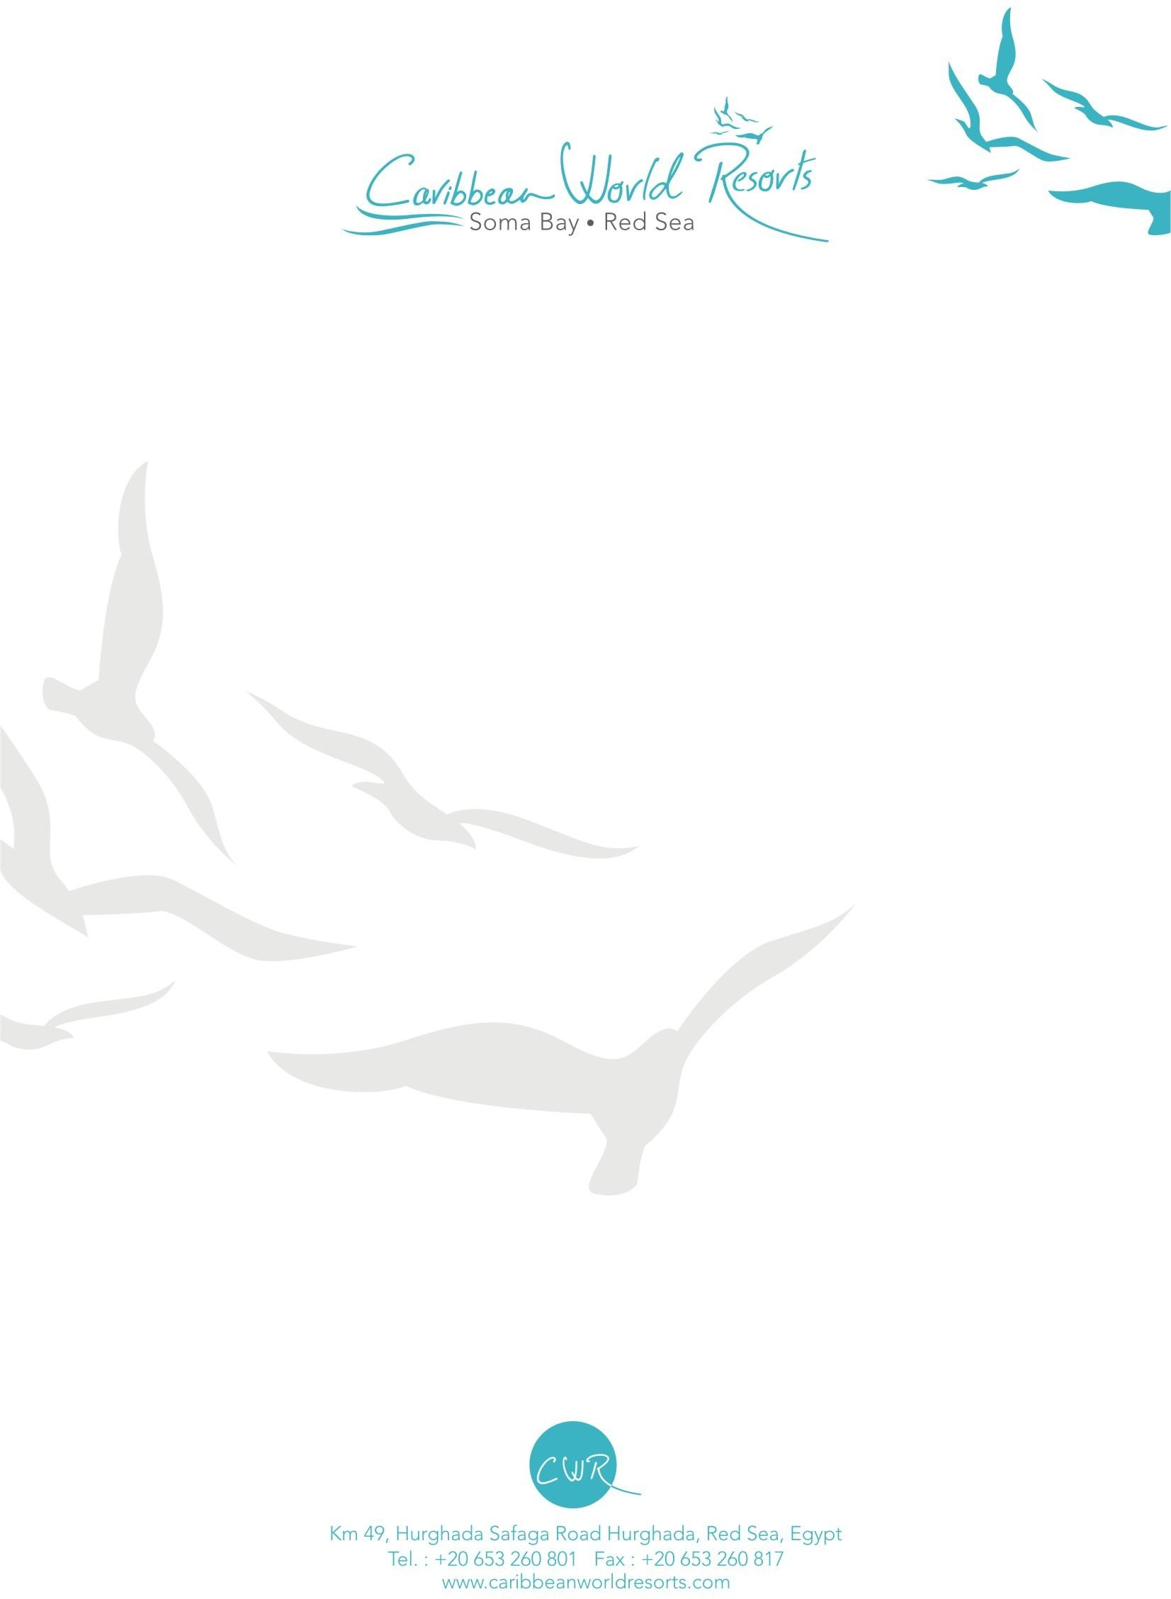
2

Kids Activities:
Kid’s daily activities program has been tailored in order to keep your kids happy and busy with our Animation Team throughout the day. Fun & interesting games have been organized for your kids at the beach. Kids/Mini Disco is available on daily basis on our Amphitheater at 20:00.

